Note: You will still need python installed on your computer: <https://www.python.org/downloads/>

Open up Sublime Text: <https://www.sublimetext.com/download>

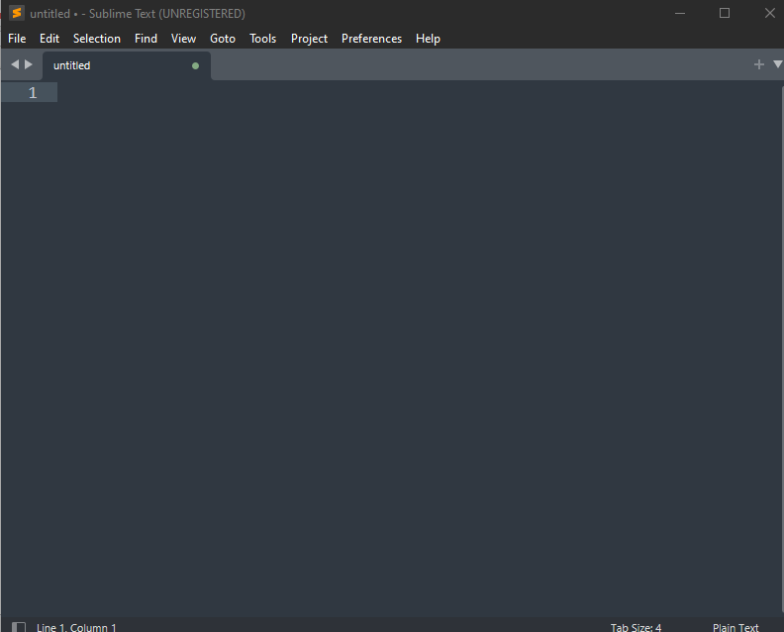

**Ctrl + S** to save file as **.py file** in the directory you want

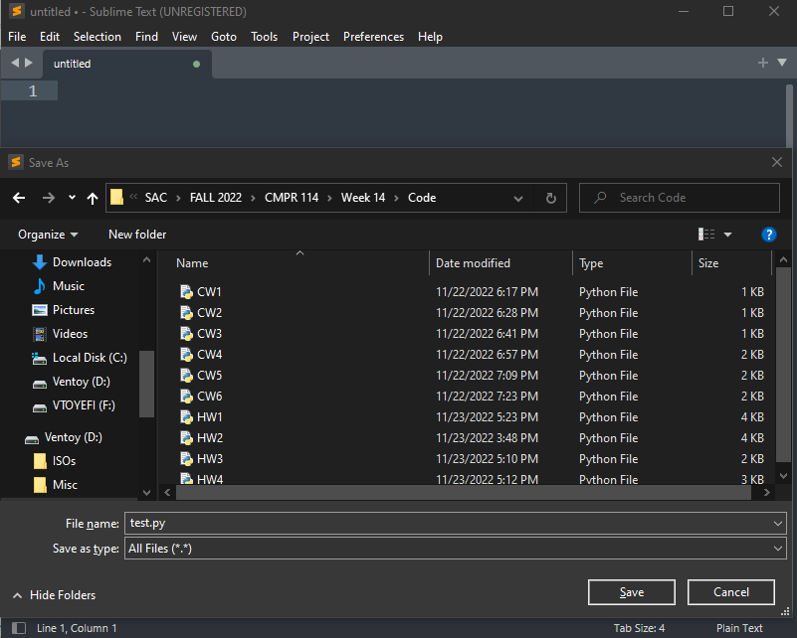  
Now type your code and **ctrl + s** because it doesn’t autosave for you

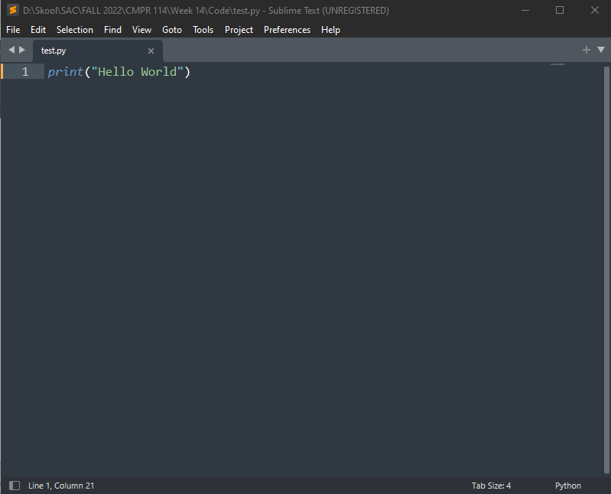You can **ctrl + scroll wheel** to make the text bigger or smaller

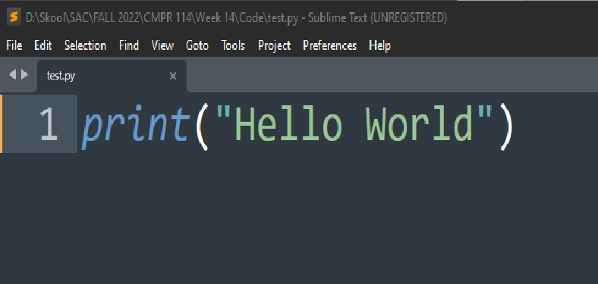

With Sublime Text you can right click and open the folder the file is in

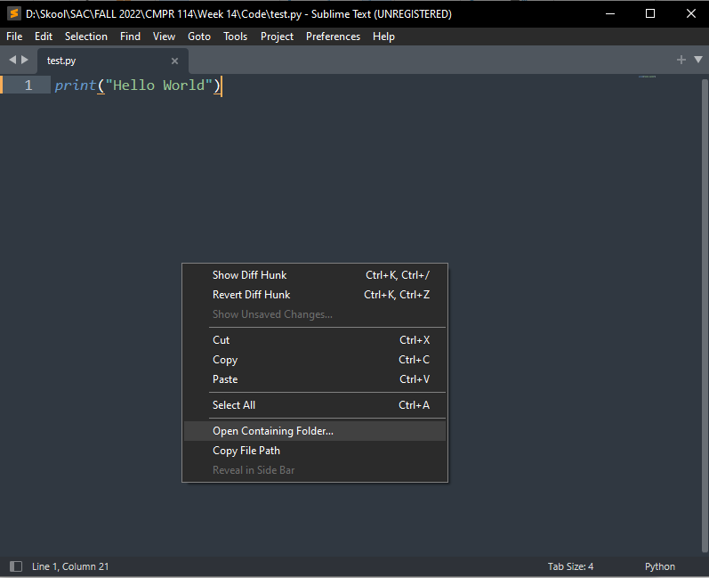  
When you are in the folder type “cmd” to open command prompt in the directory

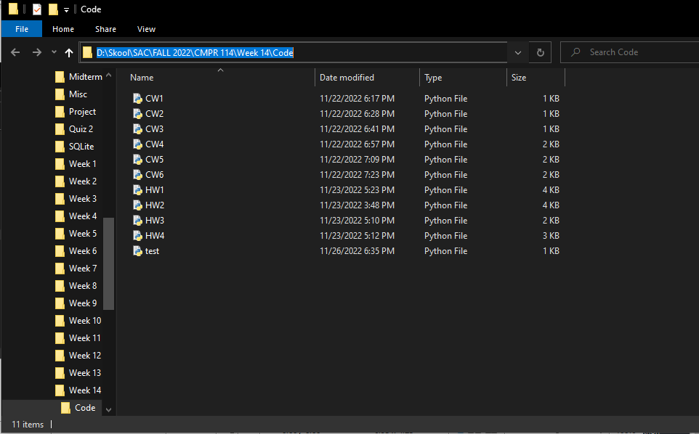

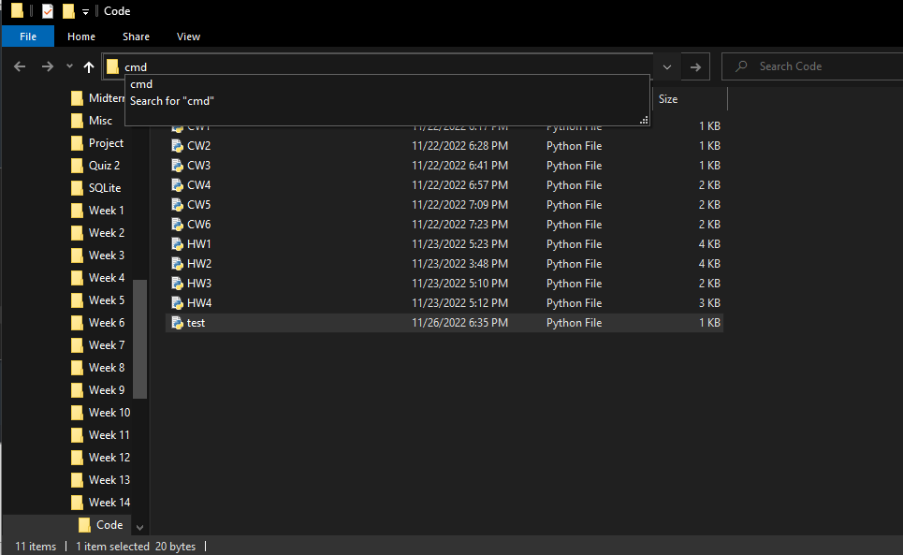  
When you are in command prompt you can type the first few letters of the file and press the **tab key** and it will autofill the rest of the file name

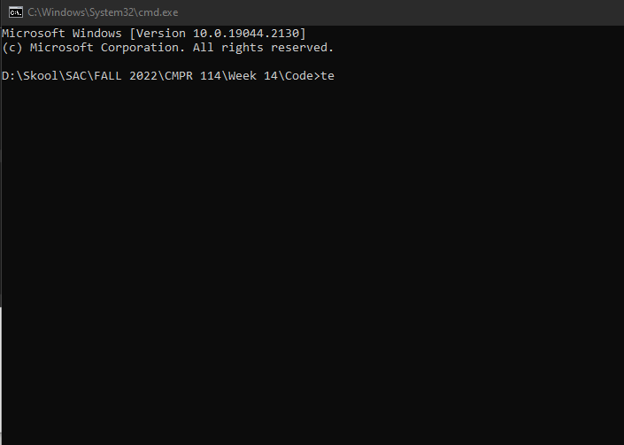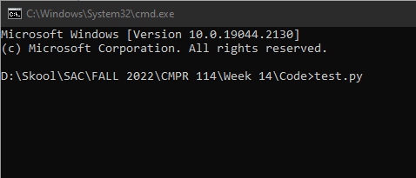

After you press enter the file should run

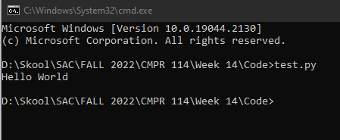

You can type “**cls**” to clear the command prompt

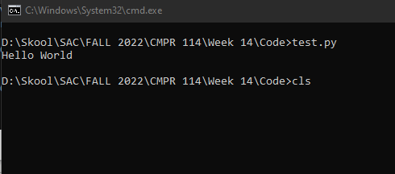

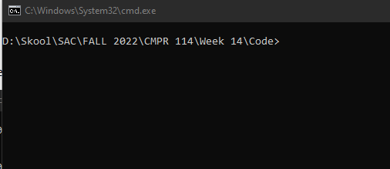

Arrow key up and down to run previous commands again

